Service discovery helps microservices locate each other dynamically at runtime. Common tools for service discovery include:

Service discovery is a crucial component in microservice architectures, enabling services to find each other dynamically at runtime. It eliminates the need for hardcoding service locations and helps with load balancing, failover, and scaling. Here's a deeper dive into service discovery, focusing on its concepts, types, popular tools, and an example implementation using Consul in .NET Core.

* **Consul**: Provides service discovery, health checks, and KV store.
* **Eureka**: Part of the Netflix OSS stack, commonly used in Spring Cloud applications.
* **Etcd**: A distributed key-value store for shared configuration and service discovery.

**Concepts of Service Discovery**

1. **Registry**: A central repository where services register themselves and their locations (e.g., IP address and port). The registry keeps track of available service instances and their statuses.
2. **Discovery**: The process by which services locate other services. This can be done through client-side or server-side discovery mechanisms.
3. **Health Checks**: Regular checks to ensure that registered services are healthy and can handle requests. Unhealthy services are typically removed from the registry.

**Types of Service Discovery**

1. **Client-Side Discovery**: Clients query the service registry to find the location of service instances. The client then uses this information to make requests directly to the service instances.
2. **Server-Side Discovery**: Clients make requests to a load balancer or proxy. The load balancer queries the service registry and forwards the request to an appropriate service instance.

**Popular Tools for Service Discovery**

1. **Consul**: A highly scalable and distributed service discovery tool that provides service discovery, health checks, and key-value storage.
2. **Eureka**: A service discovery server provided by Netflix, commonly used with Spring Cloud applications.
3. **Etcd**: A distributed key-value store used for service discovery and configuration.
4. **Zookeeper**: A centralized service for maintaining configuration information, naming, and providing distributed synchronization.

Created new project on git

new webapi -n MyMicroservice

MyService is running

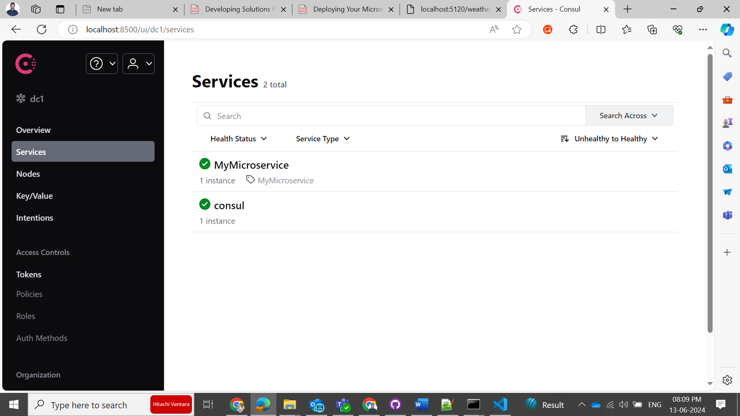

Install and extract exe and run

C:\Users\rusingh\Downloads\consul_1.19.0_windows_386>consul agent -dev

Service Details

Used to consume Microservices

dotnet new console -n MyMicroserviceClient